NH-01
2016 IE Strategy Memorandum

Updated on 5/18/16
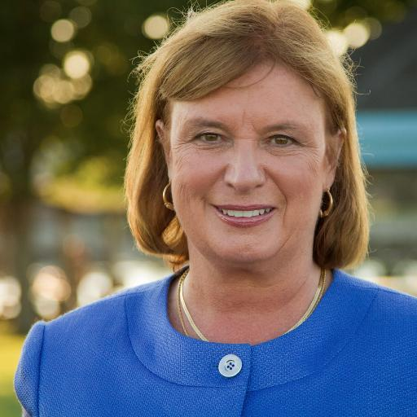
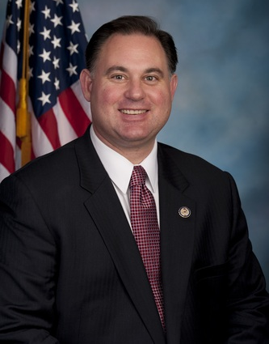

CAROL SHEA-PORTER FRANK GUINTA
CoH: $253,932.04 CoH: $76,206.68
Date: 4/15/16 Date: 4/15/16
Occupation: Former Member of Congress Occupation: Congressman

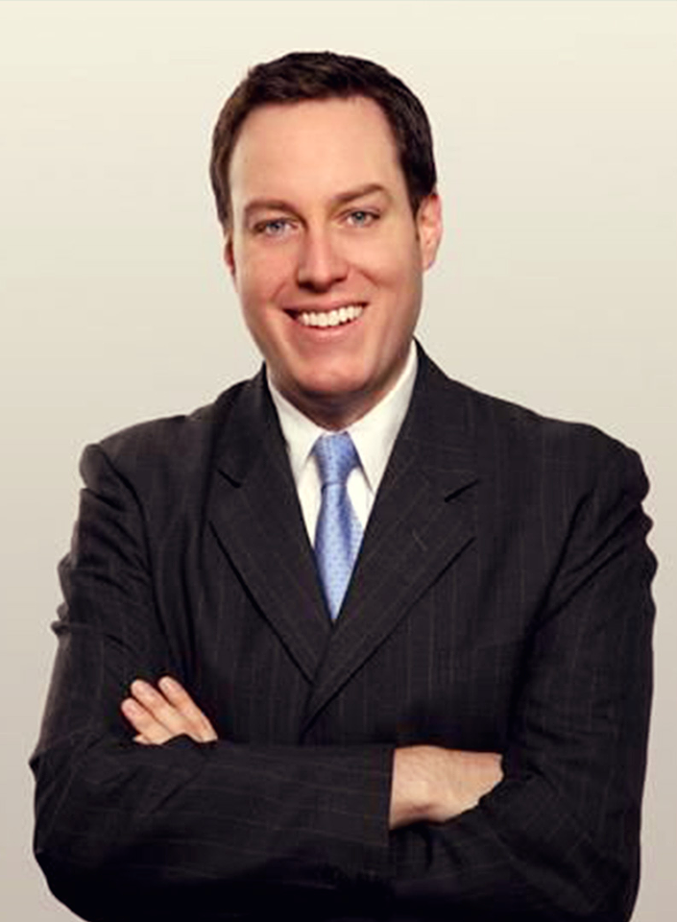
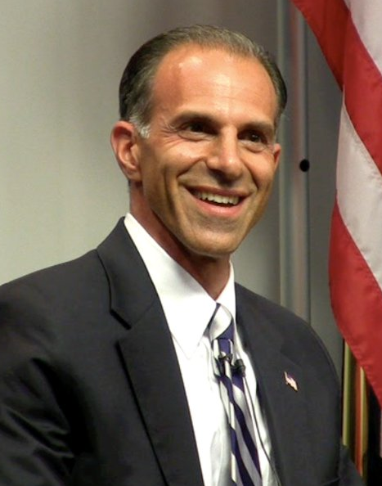

SHAWN O’CONNOR RICH ASHOOH
CoH: $722,098.27 CoH: $561.86
Date: 4/15/16 Date: 4/15/16
Occupation: Business Owner Occupation: Attorney, Executive
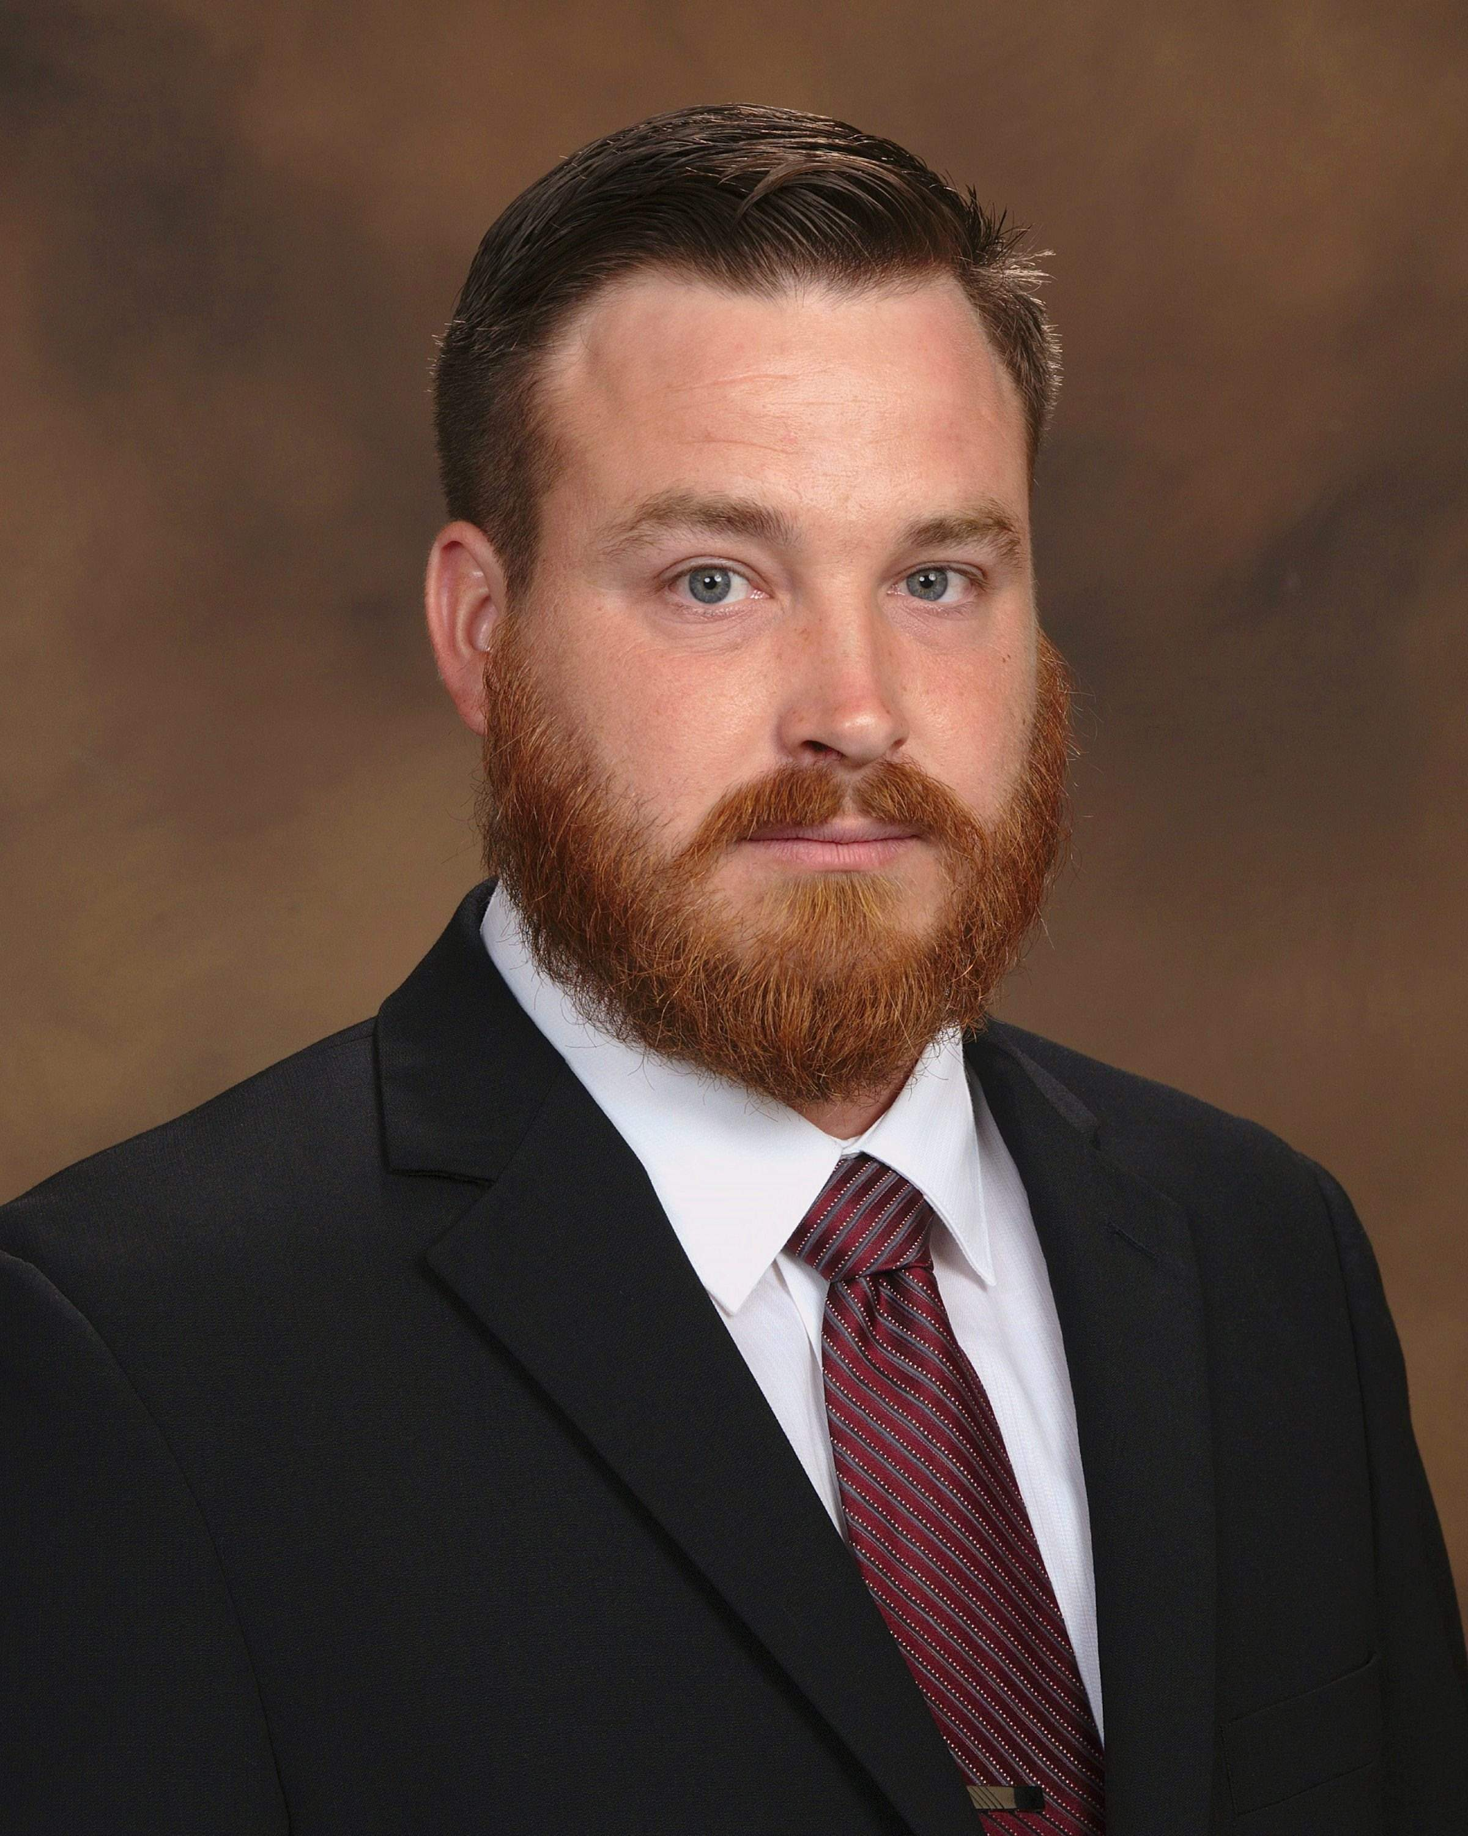

JAMIESON GRADERT
CoH: $10
Date: 4/15/2016
Occupation: Business Owner

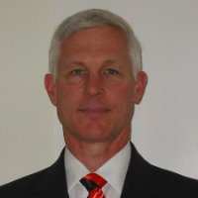

MIKE CALLIS
CoH:
Date: 4/15/2016
Occupation: Small Business Owner

SECTION I: Race Overview

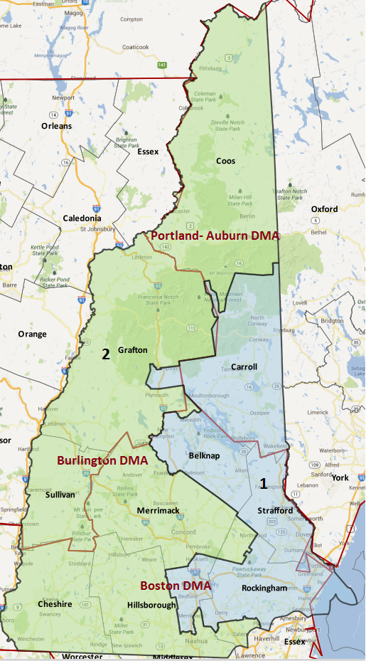
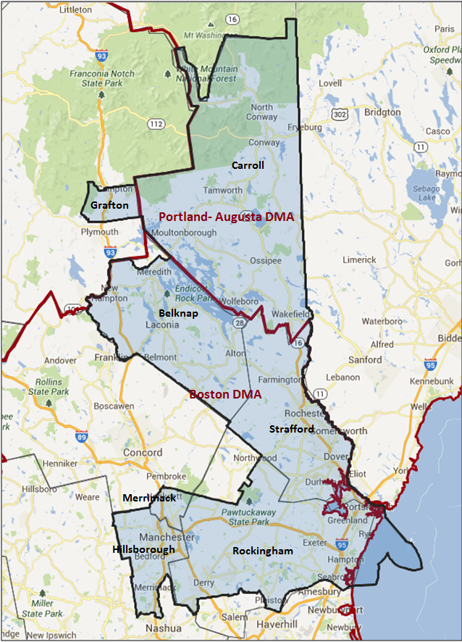

Media Market Costs

TV DMA | % of  CD | I.E.  35+ CPP | Cable CPP
BOSTON - MANCHESTER | 92% | $950 | $1100
PORTLAND-AUBURN | 8%
MANCHESTER (WMUR) | 100% | $650
NH-01 TOTALS: | 100.0%
Radio Landscape

DMA | Universe | CPP
Boston-Manchester | 172,800 | $650
Portsmouth | 242,200 | $74
Concord | 74,000 | $50

Digital Landscape
- NH-01
  - Persuasion universe size: 30,598
  - Audience extension (key demos): Independents & Democrats
  - Weekly budget for full coverage: $9,298.99
  - Reach
    - YouTube - 326,008
    - Pandora - 158,552

Presidential Statistics
Cycle | Candidate | Party | Vote
2012 | Obama | DEM | 50.8%
2012 | Romney | REP | 49.2%
2008 | Obama | DEM | 53.2%
2008 | McCain | REP | 46.9%

Congressional Statistics
Cycle | W/L | Candidate | Party | Vote
2014 | L | SHEA PORTER | DEM | 48.2%
2014 | W | GUINTA | REP | 51.8
2012 | W | SHEA PORTER | DEM | 52%
2012 | L | GUINTA | REP | 48%
2010 | L | SHEA PORTER | DEM | 42%
2010 | W | GUINTA | REP | 54%

NCEC Data
Dem Performance: 50.2%
BVAP: 1%
Hispanic: 1.9%
Asian: 1.3%
Total Minority: 4.3%

Critical Dates
Filing Date: June 10th
Primary Date: Sep 13th

Summary of 2014 Spending by Outside Groups

TV Competitive Summary – Boston

Campaign/Group | Total GRPs | Total Dollars
Carol Shea-Porter/DCCC | 35 | $37,781
NRCC | 2,921 | $3,266,285
DCCC | 1,287 | $1,998,679
House Majority PAC | 700 | $650,000
Americans for Responsible Solutions | 35 | $45,090
Congressional Leadership Fund | 637 | $997,700
Good Guys vs Bad Guys | Total GRPs | Total Dollars
Good Guys | 2,057 | $2,731,550
Bad Guys | 3,558 | $4,263,985

TV Competitive Summary – Manchester (WMUR)

Campaign/Group | Total GRPs | Total Dollars
NRCC | 2,282 | $581,850
DCCC | 1,901 | $786,966
Americans for Responsible Solutions | 215 | $96,600
Congressional Leadership Fund | 3735 | $483,700
Americans for Prosperity | 396 | $79,200
Good Guys vs Bad Guys | Total GRPs | Total Dollars
Good Guys | 2,116 | $883,566
Bad Guys | 2,963 | $1,144,750

TV Competitive Summary - Portland

Campaign/Group | Total GRPs | Total Dollars
Carol Shea Porter/DCCC | 98 | 3,326
Americans for Responsible Solutions | 50 | $2,268
Congressional Leadership Fund | 189 | $11,144
Good Guys vs Bad Guys | Total GRPs | Total Dollars
Good Guys | 148 | $5,594
Bad Guys | 189 | $11,144

DIGITAL: 23 unique pieces of digital for persuasion; the messaging always matched what was up on air. . The ads consisted of pre-roll video, Facebook, Twitter, search and banner ads. Our messaging online always matched what we were on the air with. Created 3 unique pieces of digital to run only the day before the election on WMUR, a pre-roll video and two banners.

Summary of 2014 Spending by Outside Groups

TV Competitive Summary –Boston

Campaign/Group | GRPs | Total Dollars
DCCC/CSP | 83 | $33,935
DCCC | 2,000 | $1,221,681
American Action Network | 620 | $787,440
Good Guys v Bad Guys | Total GRPs | Total Dollars
Team Blue | 2,083 | $1,255,616
Team Red | 620 | $787,440

TV Competitive Summary – Manchester (WMUR)

Campaign/Group | GRPs | Total Dollars
DCCC/CSP | 503 | $57,875
DCCC | 2375 | $925,264
Guinta/NRCC | 325 | $37,350
NRCC | 740 | $336,876
PCCC | 22 | $11,000
American Action Network | 2,564 | $1,150,500
Good guys v. Bad guys | Total GRPs | Total Dollars
Good Guys | 2878 | $983,139
Bad Guys | 3,651 | $1,535,726

TV Competitive Summary - Portland

Campaign/Group | GRPs | Total Dollars
Guinta/NRCC | 271 | $22,161
NRCC | 271 | $22,161
Good guys v. Bad guys | Total GRPs | Total Dollars
Good Guys | 0 | $0
Bad Guys | 542 | $44,322

Pre-Election Day Voting

Type of  “Early Voting” | Start Date  End Date | Percent of  Vote Cast Using this Method | Brief Description  (where/how  do people vote) | Timeframe (when does the majority of voting happen)
Absentee Ballot/In person Absentee | The completed ballot must be returned either in person by 5 p.m. the day before the election or by mail. If returned by mail, the ballot must be received by 5 p.m. on Election Day.

Tentative Campaign Timeline

IMPORTANT DATES

Absentee: Received in mail/in person Nov. 8th
Filing Date: June 10th
Primary Date: Sep 13th

SECTION II: DISTRICT OVERVIEW

- District Overview and Data

  - Political Landscape
- Over the last several cycles, this seat has passed back and forth between businessman and former Republican Manchester Mayor Frank Guinta, and former social worker and community college instructor, Democrat Carol Shea-Porter. Shea-Porter won the seat in 2006 and 2008, lost to Guinta in 2010, then won it back in 2012, after which Guinta won again in 2014.
- Currently, Guinta has been resisting calls for his resignation due to ethical concerns, and faces primary challenges from Rich Ashooh and Pamela Tucker.
- An October 8th 2015 Granite State poll shows that voters are familiar with his ethics troubles, with almost half of first district residents having heard a great deal (18%) or a fair amount (30%) about the controversy. In that poll, 21% of adults in the district have a favorable opinion of Guinta, while 50% have an unfavorable opinion. Guinta is unpopular among Republicans (net -3%), Independents (-13%) and very unpopular among Democrats (-56%). Half (50%) of the district’s residents say Guinta should resign, including 65% of Democrats, 44% of Independents, and 34% of Republicans. A majority of likely voters (56%) said they would definitely vote for someone other than Guinta, while 4% say they would definitely vote for him, 16% say they would consider voting for him, and 24% are unsure. This measure is unchanged since July 2015. Most Democrats (77%), half of Independents (50%) and a third of Republicans (33%) say they would definitely vote for another candidate.
- Carol Shea-Porter remains somewhat popular in the district – currently 37% have a favorable opinion of Shea-Porter, 30% have an unfavorable opinion, 8% are neutral and 25% don’t know enough about her to say. Her net favorability is +7%. Shea-Porter is very popular among Democrats (+50%), unpopular among Independents (-7%) and very unpopular among Republicans (-47%).
- Businessman Shawn O’Connor of Bedford is also seeking the Democratic nomination for the 1st District seat, but is largely unknown among 1st District residents. As of the same October 8th poll, 4% have a favorable opinion of O’Connor, 4% have an unfavorable opinion, 11% are neutral and 81% don’t know enough about him to say. O’Connor’s net favorability is 0%. However, he has shown a willingness to self-fund his campaign and is leading among all candidates in COH.

  - District Demographics
- The majority of voters in New Hampshire’s 1st Congressional District live in its southern half, centering on Manchester in the southwest and up along the Maine border near the coast, in the Rochester and Portsmouth areas.
- Key areas include the base county of Strafford, particularly the city of Dover, Derry, Londonderry, and Portsmouth in Rockingham County, and Manchester and Merrimack in Hillsborough County.
- The voters of New Hampshire’s 1st Congressional District are largely White, suburban or rural, and on balance wealthier than the country as a whole. Voters with household income over $100,000 have comprised 40-42% of the electorate in the last four election years, while voters with household income under $50,000 have comprised 23-25%. Rockingham County has the highest proportion of higher-income voters, while Strafford and Hillsborough voters are more equally distributed in terms of household income. By party registration, the district is 26% Democrat, 31% Republican, and 43% independent or unaffiliated.

District Demographics

- Cook Partisan Voting Index: Tossup - R
- Urban Population: 8.5%
- Rural Population: 64.2%
- Suburb Population: 27.3
- Median Income: $67,083
- Poverty Status: 5.3%
- Military Veterans: 11.9%
- Race/Ethnic Origin: 95.8% White; 1% Black; 1.3% Asian; 1.9% Hispanic Origin

  - Electoral Context
- New Hampshire is expected to be a hotbed of presidential program activity in 2016, which will help raise Democratic turnout. The 1st District is critical to the statewide path to victory and will see investment, but it is slightly less important than the 2nd district. President Obama won this district with 50.8% and 53.2% of the two-way vote in 2012 and 2008 respectively, while John Kerry and Al Gore earned 48.9% and 48.4% of the current district’s two-way vote in their respective elections.
- New Hampshire will have both competitive Senate and Gubernatorial races in 2016. Sitting Governor Maggie Hassan is challenging incumbent Senator Kelly Ayotte. Democrats have controlled the Governor’s seat for almost a decade, but the New Hampshire governor’s race is rated a “Tossup” by cook political report. Both parties have primaries to select the nominee.
- In order to win statewide in 2016 without winning the 1st district, a Democrat would need to plan to win the 2nd Congressional District with 54.2% in a two-way vote. In competitive elections, this mark has been hit in the 2nd district by the following statewide Democrats: Obama in 2012 and 2008, Shaheen in 2008, Lynch in 2010, and Hassan in 2012. However, none of these Democrats lost the 1st district, with Obama’s 2012 campaign performing the worst there, with 50.8%. Other Democrats winning recent statewide elections have won the 1st with 53.2% (Obama in 2008), 51.7% (Shaheen in 2008), 52.2% (Lynch in 2010), and 54.4% (Hassan in 2012). In 2004, both John Kerry and John Lynch won statewide while losing the 1st district, but each won uncomfortably narrow statewide victories of 50.7% and 51.1% while earning 48.9% and 48.7% in the 1st district. A reliable plan to win the state would include winning the 1st district.
- In Rockingham and Hillsborough counties at large, a Democrat must either hold even or lose by a narrow margin in order to stay competitive districtwide. For example, in 2012 President Obama won Hillsborough with 50.3%, and the district with 50.8%. The only other counties he won that year were vote-poor Grafton, and reliably Democratic Strafford. The President received 47% in Rockingham in that year. Also in 2012, which is Shea-Porter’s only victory against Guinta, she won Rockingham with 51.3% and Hillsborough by 31 votes, or 50.02%. She also won Strafford with 59.1%.In Rockingham County, Portsmouth is a base city to drive up turnout, while a Democrat should seek to stem losses in the less-favorable Derry and Londonderry. Hillsborough County includes Manchester, the most populous city in the district, which has been reliably Democratic in the last two Presidential years. Earning strong support in Manchester is key to victory.
- There is currently only one scheduled ballot initiative, a Vote in Presidential Primary Amendment (Suffrage). The initiative is unlikely to affect Democratic turnout.

  - Press Presence

- The district is located within three media markets. The Boston (Manchester) market covers 92% of the district, and has a political CPP $675 and an issue CPP of $810. It includes the district’s southern and central counties of Hillsborough and Rockingham, Merrimack, Strafford, and Belknap. The Portland-Auburn market to the north, covering Carroll County at the remaining 8% of the district, has a political CPP of $135, and an issue CPP of $162. WMUR covers 100% of the district at a (current) rate of %650 CPP. The Boston market, in particular, is expected to be very crowded and expensive; there have already been reports of prices rising and advance buys being declined in anticipation of higher prices later. A very small piece of the district, Grafton County at less than 1% of the expected electorate, can also be found in the Burlington-Plattsburg market in the northwest. While an efficient strategy will save money on paid media by buying points in the Portland-Auburn market, the expensive Boston market is unavoidable in this district, as it comprises 92% of expected voters.
- The presidential, senate, and gubernatorial races will command the airwaves in NH-01. Breaking through in an expensive and crowded media market will be difficult. It will be vital to include the overall view of spending in the district before making decisions on issues/spending.
- WMUR plays a major factor in this district. Notorious for their expensive CPP it covers 100% of the district and is separate from normal broadcast and cable buying.

SECTION III: MESSAGE

Message Box

Democrat Self Frame  I’m running again because I have the experience, the competence, and the integrity to serve the rest of us and to fight against special interests.  I believe that affordable education creates prosperity, that renewable energy is key to our economic and national security, and that sending manufacturing jobs overseas hurts American workers and small businesses. Investing in infrastructure, fostering job creation, and fair pay are good business decisions and good moral decisions, and that we can reduce the debt without dismantling essential programs. The current Republican-controlled House of Representatives obstructs legislation that will help average Americans and bows to special interests instead of focusing on job creation and good government. | Republican Self Frame  While serving New Hampshire in Congress, his top priority was growing the middle class. He worked to achieve this goal in a number of different ways. Namely, he fought to repeal and replace Obamacare, which continues to devastate the middle class through a combination of taxes, a reduction in the workweek while also putting in place barriers for hiring that hamper small business growth. Frank also began his "Getting Granite Staters Back to Work" Initiative, through which, he held six job fairs including one specifically for military veterans, a Women’s Conference and several Manufacturer's summits as well. As your Congressman, Frank will continue fighting to protect and preserve Social Security and Medicare to ensure that future generations have access to these vital programs.
Likeliest Attacks on Democrat  Carol Shea-Porter loves to preach what she doesn’t practice. Always quick to call for “bipartisanship,” Shea-Porter almost always voted against bills that have support from both sides of the aisle. In fact, she votes with Nancy Pelosi 98% of the time. Shea-Porter has even broken with her own fellow New Hampshire Congresswoman and voted against a bill that prevents Members of Congress from receiving pay if they don’t pass a budget and another bill that prevents Congress from raising the debt limit in order to pay Congressional salaries. | Best Attacks on Republican  Guinta has been called on by both parties to resign after an ethics scandal. He used $355,000 of his parent’s money to run his 2010 campaign.  Called for privatization of Social Security, ending Medicare as we know it, and defunding of planned parenthood.

- Carol Shea-Porter

- Short Biography
Born in New York City, Carol Shea-Porter earned her undergraduate and graduate degrees from the University of New Hampshire. Before elected to Congress Shea-Porter was an activist, social worker, and professor.

- Self-Frame
I’m running again because I have the experience, the competence, and the integrity to serve the rest of us and to fight against special interests. I never take money from corporate PACs and DC lobbyists.
I believe that affordable education creates prosperity, that renewable energy is key to our economic and national security, and that sending manufacturing jobs overseas hurts American workers and small businesses. I believe that investing in infrastructure, fostering job creation, and fair pay are good business decisions and good moral decisions, and that we can reduce the debt without dismantling essential programs. The current Republican-controlled House of Representatives obstructs legislation that will help average Americans and bows to special interests instead of focusing on job creation and good government.

- Likely Attacks
Carol Shea-Porter loves to preach what she doesn’t practice. Always quick to call for “bipartisanship,” Shea-Porter almost always voted against bills that have support from both sides of the aisle. In fact, she votes with Nancy Pelosi 98% of the time. Shea-Porter has even broken with her own fellow New Hampshire Congresswoman and voted against a bill that prevents Members of Congress from receiving pay if they don’t pass a budget and another bill that prevents Congress from raising the debt limit in order to pay Congressional salaries.
A well-documented liberal voting record.

- Assessment of Democratic Fundraising
MEMBER/CANDIDATE | CYCLE RAISED | CYCLE SPENT | Q1 RAISED | COH
Carol Shea-Porter | $495,982.38 | $297,369.45 | $175,830.13 | $253,932.04

DEMOCRAT | Q1 2015 | Q2 2015 | Q3 2015 | Q4 2015 | Q1 2016
Goal |  |  | $250,000 | $300,000 | $350,000
Actual Raised | $9,850 | $2,740 | $86,456 | $211,137 | $175,830.13

- Strengths and Weaknesses of Campaign
Strengths
- Shea Porter and her campaign have deep ties to the activist community in New Hampshire and the candidate is a proven winner in presidential years.
- Name ID

Weaknesses
- Major fundraising issues
- Liberal voting record
- The campaigns weakness is well documented. While they are strong with the grassroots community, they struggle with basic campaign mechanics. The candidate has been known to change shoot scripts on the day of shoots. Likewise, the candidate is unwilling to do basic fundraising via phone and online which hampers the campaign’s ability reserve/buy TV in what will be an expensive media market.
- Voter fatigue. Shea-Porter has been running in this district since 2006.

- Shawn O’Connor

- Short Biography
Shawn received his Master’s in Business Administration with Highest Honors (Baker Scholar) from Harvard Business School and his Juris Doctor, cum laude from Harvard Law School. Shawn graduated summa cum laude and Phi Beta Kappa from Georgetown University’s Walsh School of Foreign Service where he majored in international politics. Shawn is admitted to the bar in a number of states.
Shawn is the founder of Stratus Prep, the world’s leading independent test preparation and admissions counseling firm. Shawn launched Stratus Prep from a small apartment with just $5,000, his entire life savings at the time. The multi-million dollar company was recently named (for the second consecutive year) to the Inc. 5000 (a list of the 5,000 fastest-growing private companies in the nation)

- Self-Frame
Shawn O'Connor is a successful educational entrepreneur, a proven job creator, and an active community leader who is deeply committed to bridging the partisan divide in Washington in order to facilitate the passage of pragmatic public policies that will ensure affordable, high quality healthcare as well as economic and educational opportunities for all “Granite Staters” and Americans.

- Likely Attacks

- Assessment of Democratic Fundraising
MEMBER/CANDIDATE | CYCLE RAISED | CYCLE SPENT | Q1 RAISED | COH
Shawn O'Connor | $1,249,936.93 | $527,838.66 | $44,848.56 | $722,098.27

- Strengths and Weaknesses of Campaign
Strengths
- Self-Funder
- COH advantage
- Business Owner

Weaknesses
- Name ID
- Seen as inexperienced and opportunistic

- Frank Guinta

- Short Biography
Graduated from Franklin Pierce with masters in intellectual property. Was elected alderman and mayor of the city of Manchester before running for congress.

- Self-Frame
While serving New Hampshire in Congress, his top priority was growing the middle class. He worked to achieve this goal in a number of different ways. Namely, he fought to repeal and replace Obamacare, which continues to devastate the middle class through a combination of taxes, a reduction in the workweek while also putting in place barriers for hiring that hamper small business growth. Frank also began his "Getting Granite Staters Back to Work" Initiative, through which, he held six job fairs including one specifically for military veterans, a Women’s Conference and several Manufacturer's summits as well. As your Congressman, Frank will continue fighting to protect and preserve Social Security and Medicare to ensure that future generations have access to these vital programs.

- Best Attacks

Republican Candidate | Ryan Budget(s) – (Include if its Votes or Statement) | Privatize Social Security | Defund Planned Parenthood | Anti-Choice Position
Frank Guinta | Both budgets - Votes | Yes | Yes | Yes
Rich Ashooh

Frank Guinta Top Hits
- Frank Guinta used $355,000 of his parents money to illegally fund his 2010 campaign-was fined $15,000 by the FEC. Members of both parties have called on him to resign.
- Lots of press coverage of Guinta’s FEC troubles.
- See “The Case Against Frank Guinta” in NH-01 Updated Research Book.

- Rich Ashooh

- Short Biography
Rich Ashooh was born and raised in Manchester and is a graduate of the University of New Hampshire. He lives in Bedford with his wife, Lori, and they have five children, Sofie, Emma, Elias, Maya, and Sam.﻿ Rich Ashooh is a senior executive at BAE Systems, a global aerospace company that is New Hampshire’s largest manufacturer and one of its top private employers. During his 15 years of service, BAE has grown to a nearly $5 billion enterprise, employing thousands of workers.

- Self-Frame
“The excessive spending in Washington and incomprehensible national debt have awakened voters to the reckless policies being pursued by Congressional Democrats. If we are to overcome the enormous challenges that lie ahead, we must elect leaders who will listen to their constituents, make tough decisions, and solve problems without accruing massive debt, raising taxes, suppressing innovation, and stifling job creation.” Ashooh continued, stating, “Before we can address issues such as improving health care, we must first get our fiscal house in order.”

Rich Ashooh Top Hits
- Has said he won’t endorse a presidential candidate until the nomination process is over, said he disliked the “tenor” of this election cycle.
- Held house parties for Chris Christie, Jeb Bush, and Carly Fiorina ahead of the New Hampshire primary.
- Calls for a smaller government and reduced spending but was a lobbyist who sought federal contracts for a major defense contractor.

SECTION V: Appendix

- 2016 Campaign Side Consulting Team
Media: Pia Carusone/The Campaign Group
Mail: Jim Crounse
Polling: Jef Pollock/Global Strategies Group
Online/Digital: Revolution Messaging
Self-research: Global Strategies Group

- Summary of Past Races and Important Differences for 2016
Recent Elections
In 2012, President Obama won the district with 50.8% of the two-way vote, and Hillsborough County with 50.3%. The only other counties he won that year were vote-poor Grafton, and reliably Democratic Strafford. The President also received 49.3% in Rockingham. Meanwhile in the 2012 Congressional race, Shea-Porter’s only victory against Guinta, she outperformed the president in every significant area except the city of Manchester, garnering 54.8% to Obama’s 55.6% within the city. Her 52.0% of the vote over-performed the 2012 DPI of 48.5% by 3.5 percentage points, and she did especially well in Hillsborough and Rockingham (over-performance of 3.9 points and 3.4 points respectively, winning both counties when 2012 DPIs were 46.2% and 47.9%.). Districtwide, turnout driven by the presidential campaign exceeded 2008 by about 4,000 votes.
In 2014, Shea-Porter again won Stafford, but only with 54.8% of the two-way vote, and lost Hillsborough and Rockingham with 47.0% and 47.1% of the two-way vote respectively. The only other county she won was Grafton, a solidly Democratic but small county. Fundraising was an issue on the campaign side, and high-and-rising prices for WMUR and the Boston media market made it cost-prohibitive for the IE to buy more points after late tracking showed that Shea-Porter was still in the race. This was partially due to a high number of campaigns competing for Boston airtime, including Massachusetts governor and congress, NH-01, NH-02, and New Hampshire governor, and partially due to Republican groups viewing this as the easier of the two NH races for them and spending a good deal of money here. Future campaigns should consider buying more early with the intent of cancelling if necessary, considering that the market is 92% of voters, it cannot be avoided when playing in this district.
Shea-Porter’s 2014 campaign earned less support than her 2012 campaign in every county, most notably she lost a disproportionate amount of support in the Democratic bastion of Strafford County, where support dropped from 59.1% to 54.8%. Of the major towns in Strafford, she earned 6.5 fewer points of support in Rochester, 2.8 fewer in Dover, and 6.2 fewer in Somersworth. While Strafford had the largest percentage-point drop in support of any county, Rockingham’s drop in support cost the most votes, losing the most ground in Derry and Londonderry. Hillsborough ran a close third in terms of the amount of support lost, with a drop of 3.0 percentage points. Manchester, the district’s major population center, went from 54.8% support in 2012 to 52.0% in 2014.

Role of the I.E.
Given the polling, we saw that there was a chance to keep the seat, and knew that to do so, the IE would need to make a significant investment (balanced against the needs in other districts as prices for WMUR and in the Boston market rose at the end of the campaign).

We took direction from the poll to work to define Guinta based on his past ethics troubles. Rather than playing into the national dynamics that threatened to dominate the race, we focused not on Guinta’s partisanship or policy positions, but rather on ethics charges that we hoped would disqualify him in the minds of voters.

NH-01 has followed the national waves and this year was no different— from the beginning we knew this race would be a toss-up. It was a rematch of two known quantities; voters were familiar with both candidates as this was their third race against one another—a dynamic that helped with the sense that this race was less about the dynamics of the district and more about how a moderate district felt about the direction of the nation. Throughout the cycle, national media had pegged this race as a seat likely to change hands. However, our polling showed that this would be a winnable, which informed our decision to plus up our buy in Boston and Manchester, and in the end, it was a closer loss than many other districts that were viewed as easier for Democratic incumbents to hold. Unfortunately, while we had placed an early buy here, by the time we tracked and saw that Shea-Porter was still in the race, it was cost-prohibitive to add more to the WMUR or Boston buys. Additionally, GOP outside groups viewed NH-01 as we did—the easier of the two New Hampshire districts for them to win. They poured funds in against Shea-Porter (more so than against Kuster), making it nearly impossible to match their spending, but also allowing us to make investments in NH-02 that led to a win there (this flouted the conventional wisdom that these two districts inevitably rise and fall together).For future cycles, buying more early in these districts, with the specific intent of cancelling if need be, would be prudent.

2016 Targets
DEMOCRATS START THIS RACE FUNCTIONALLY TIED (49.7% TWO-WAY SUPPORT), AND NEED ABOUT 7,770 VOTES TO ACHIEVE 52% SUPPORT. VICTORY DEPENDS ON THE FOLLOWING:
- EARN 91% SUPPORT AMONG REGISTERED DEMOCRATS, 62% SUPPORT AMONG REGISTERED INDEPENDENTS, AND 9% SUPPORT AMONG REGISTERED REPUBLICANS
- RAISE SUPPORT IN ROCKINGHAM COUNTY TO 51.5%, FOCUSING IN LONDONDERRY, PORTSMOUTH, HAMPTON, AND DERRY
- RAISE SUPPORT IN HILLSBOROUGH COUNTY TO 50.5%, FOCUSING IN MANCHESTER
- RAISE STRAFFORD COUNTY SUPPORT TO 58%, AND BRING TURNOUT TO 77%, FOCUSING IN ROCHESTER, DOVER, AND DURHAM
- HOLD SUPPORT AT 49% IN BELKNAP COUNTY, AND 51% IN CARROLL COUNTY
- EARN AT LEAST 54% SUPPORT AMONG WOMEN
- MAINTAIN SUPPORT AMONG VOTERS AGED 45+ TO A FLOOR OF 49%
- INCREASE TURNOUT AMONG VOTERS AGED 18-29 BY 3 POINTS, to 74%, AND MAINTAIN SUPPORT AT 54%

